7.48: (a)
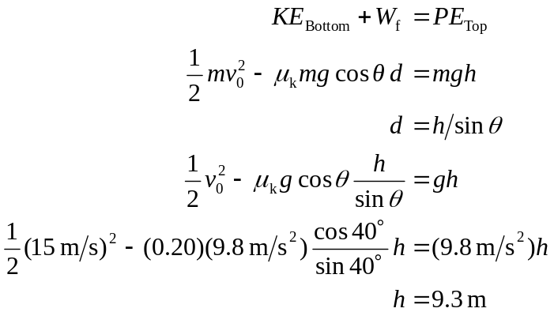
(b) Compare maximum static friction force to the weight component down the plane.
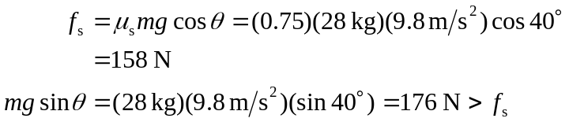
so the rock will slide down.
(c) Use same procedure as (a), with 